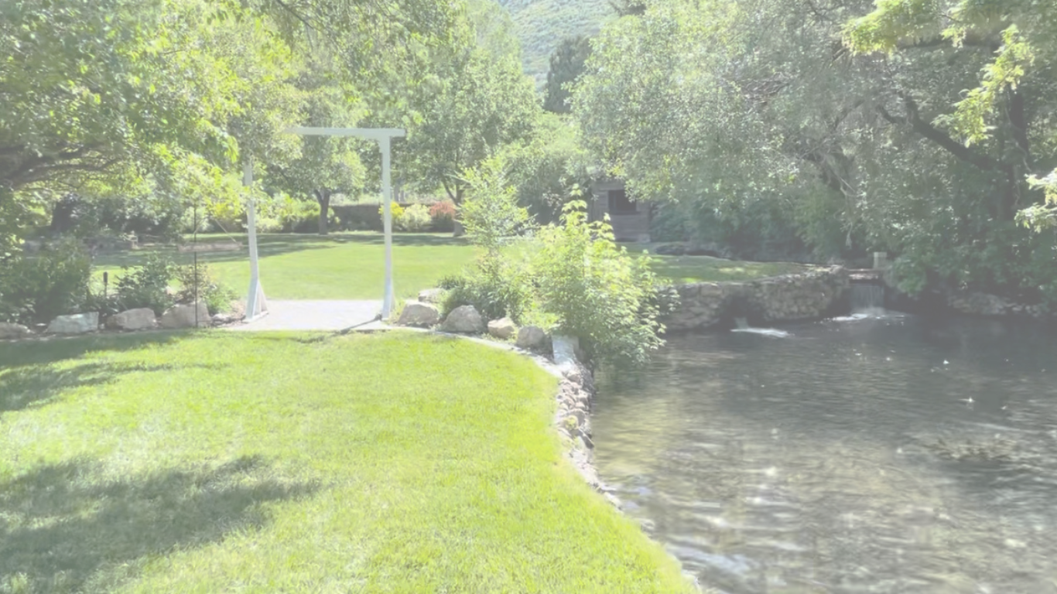
East Venue Wedding Details
Pricing
Our pricing is:
• Monday thru Saturday-$1,500/day
50% is required to hold the date. The remaining 50% split into monthly payments with the final due two weeks before the event date.
The cleaning fee is $100.00. It is refundable IF:
1. Pick up all visible trash
2. Take garbage bags to dumpster
3. Remove all items from our facility that were brought in by your party.
4. All items rented through Cold Springs Trout Farm are returned in proper condition.
Details of the Area
You can access the area from 9:00 am until 10:00 p.m.
- 2500 sq ft of finely chopped, enclosed bark area.
- Rustic Privacy Wall
- Large mature Trees and Fire Pit.
- Featured Gristmill with Access to 15 amps of power.
- Large Grassy Area surrounded by Water and Landscaping Features
Additions to Your Event
• Up to 12- 6′ long lifetime tables with the benches attached.
• Up to 50 lifetime chairs
• Two Serving tables- (8′ long)
• Bluetooth Speaker with a Microphone
• Lawn Games (including bocce, jumbo checkers and life-size jenga)
• Fish Food Pail
• Parking for up to 100 guests.
Wedding Venue Waiver
Music:
o We are in a residential area therefore music must only be background music only, no louder than 65 dB.
o Cold Springs Trout Farm reserves the right to stop the music if complaints are received.
o Absolutely no live bands or DJ’s
o Due to North Ogden’s after hour’s noise ordinance, music may be required to be turned
down after dusk.

Food:
o No alcoholic beverages, no exceptions.
o There is no running water in this area. You will need to provide water for your guests.
o Clean-up is required.
o If your party is catered, it must be approved by emailing us at fishcstf@msn.com.
Parking:
o We have two lots. However, we ask you use the main parking lot west of the venue first as it is
closer to the East Venue and designated for such parties. The one to the south of the area is often used as overflow or designated for bowery parties.
Damages:
o Additional fees will be charged if damage is done to our facility or decorations rented, by you
or your partygoers. If items or grounds are damaged, the card on file will be charged to
restore or replace said item or damage.
Additional Information:
o Bathrooms are located to the west of the fishing building. They are open to all guests attending our Farm. There are two wheelchair accessible, unisex bathrooms.
o We do not allow alcohol, sparklers (open flames), confetti or driving on the grass.
o If decorating the gristmill or wood features, please use upholstery tacks only.

