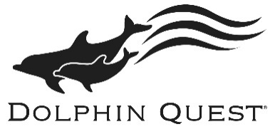
Dolphin Quest Bermuda - Internship Application
Please fill in the following information and rename the file with your full name when saving this document:
Full Name
Street Address
City
State
Zip Code/Country Code
Country
Citizenship
Cell Phone Number
Time Zone
Email

University
Major
Graduation Date or Expected Graduation Date

Describe specialized training or certifications (CPR/First Aid), apprenticeships, skills (swimming) and/or extracurricular activities, involvement in organizations (IMATA, AZA) that are relevant.
Session Preference (please check):
2019 – Session 1 (1/14/19 to 5/10/19)
2019 – Session 2 (5/13/19 to 9/6/19)

Internship Program Preference (please check):
Marine Mammal Internship
Marine Conservation Education Internship (offered 2019 Session 2 only)

I have noted the beginning and ending dates of this program, have checked my college schedule, and understand that I am committing to complete the entire program. I further understand that not completing the commitment will result in an incomplete for the internship.
Please type your initials here ___________

Reference Name | Phone Number | Email

How did you hear about our internship program? Please check all that apply.
 | Internet search (Google, Bing, etc.) |  | IMATA – web site or at conference
 | Participation at Dolphin Quest |  | Other organizations (like IMATA)
 | Word of mouth |  | Other (please list details below)

