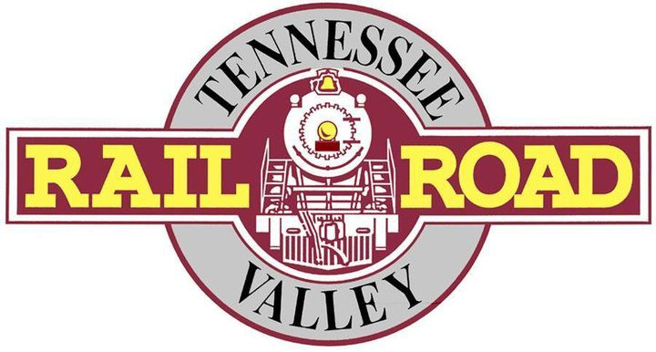
Volunteer Application
Please submit to:
Tennessee Valley Railroad Museum
Attn: Zachary Langley
4119 Cromwell Rd
Chattanooga, TN 37421
Phone: (423) 894-8028
Or email: zlangley@tvrail.com
ncooper@tvrail.com

Section 1
Date of Application: ________________________________________________________________________
Name: __________________________________________________________________________________
Address: ________________________________________________________________________________
City: _________________________________________________ State: _______ Zip Code: _____________
Phone Number: _________________________________ Email: ____________________________________
Emergency Contact (Name, Phone, Email): _____________________________________________________
________________________________________________________________________________________
Availability for Volunteering (Dates, Hours, Frequency): ___________________________________________
________________________________________________________________________________________
VOLUNTEER PREFERENCES (Check all that apply):
- Greeter – Greets guests and answers questions when they first enter the property at Grand Junction.

- Car Host – Works with train staff on board to assist with customers and provide additional support.

- Tour Guide – Lead tours through the day on the Missionary Ridge Local train ride.

- Event Staff – Helping with special events in various positions throughout the year.

- Other (Please Specify): ______________________________________________________________

Section 2
Are you a U.S. Citizen? Yes No
Are you over 18 years of age? Yes No
Have you been convicted of a felony? Yes No
If yes, please explain: ______________________________________________________________________
________________________________________________________________________________________
________________________________________________________________________________________

Due to the historic nature, the Tennessee Valley Railroad Museum’s railroad equipment is not ADA compliant.
Safety for our guest and our employees is TVRM’s first priority. Volunteers at TVRM must adhere to TVRM’s stringent safety rules and culture, and must demonstrate the ability to think and act quickly in the best interest of guest and employee safety. TVRM may remove volunteers from service who demonstrate a lack of willingness or ability to support and advance our safety culture.

Please list previous/current work or volunteer experience:
Employer: _______________________________________________________________________________
Address: ________________________________________________________________________________
Supervisor’s Name, Phone number, and Email: __________________________________________________
________________________________________________________________________________________
Paid or Unpaid Positions: ___________________________________________________________________
Duties: __________________________________________________________________________________
________________________________________________________________________________________
Reason for leaving: ________________________________________________________________________

Employer: _______________________________________________________________________________
Address: ________________________________________________________________________________
Supervisor’s Name, Phone number, and Email: __________________________________________________
________________________________________________________________________________________
Paid or Unpaid Positions: ___________________________________________________________________
Duties: __________________________________________________________________________________
________________________________________________________________________________________
Reason for leaving: ________________________________________________________________________

Why do you wish to volunteer for TVRM? _______________________________________________________
________________________________________________________________________________________
What relevant talents and skills do you bring to the organization? ____________________________________
________________________________________________________________________________________
Have you ever been disciplined, suspended, or discharged from previous employment or volunteer work? Yes No
If yes, please explain: ______________________________________________________________________
________________________________________________________________________________________
Section 3
Acknowledgement
If volunteering, I will honor all Tennessee Valley Railroad Museum (TVRM) volunteer policies and guidelines. I will be dependable and present during my assigned volunteer duties and times. I hereby authorize present and former employers, associates, schools, law enforcement agencies, military organizations, and/or other persons and organizations to provide TVRM with any information which may aid in determining my suitability for volunteer duties. I release those individuals and/or organizations contacted from all liability whatsoever for issuing the requested information, and hereby waive for right to receive written notice on any such information provided. I also hereby release TVRM, its affiliates, and employees from any and all liability and damages for requesting, releasing, and using information concerning me, my work, and performance record. The answers given on this volunteer application are in all respects true, complete, and accurate. I understand any false statements made, or upon discovery of such false statements or omissions, may result in my being removed from duties and museum premises.
I agree to hold harmless TVRM and its employees, volunteers, and/or representatives for all damages, claims, losses, or other liability due to personal injury or death or damage to property. I further acknowledge that I will assume responsibility for any damages I cause to any TVRM buildings, property, and facilities or the same of any visitor, representative, employee, and/or volunteer to the museum.

Volunteer Signature: ______________________________________________________________________

Date Signed: ____________________________________________________________________________

