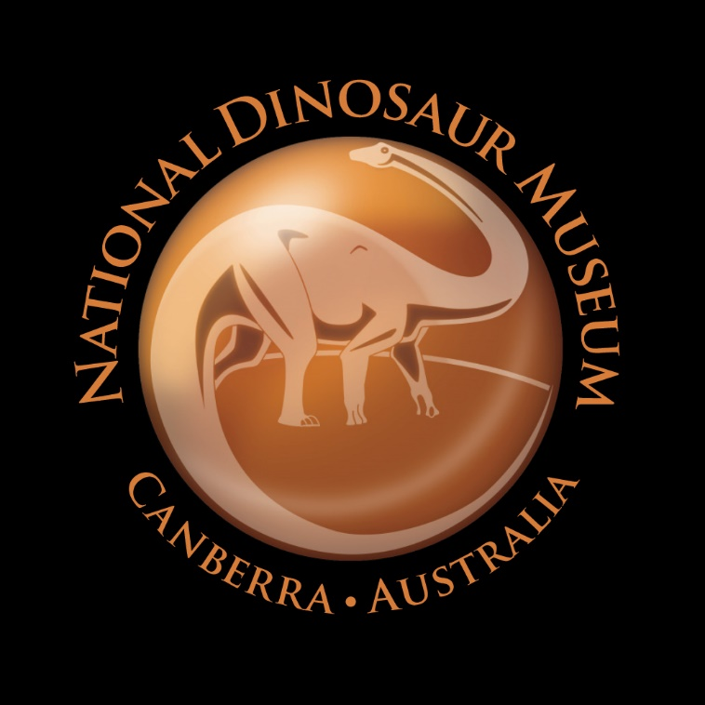I

Venue information
National Dinosaur Museum
6 Gold Creek Road, Nicholls, ACT 2913
Tel: 02 6230 2655
Email: admin@nationaldinosaurmuseum.com.au
Website: www.nationaldinosaurmuseum.com.au

Getting there
The National Dinosaur Museum is conveniently located in Gold Creek Village at 6 Gold Creek Road, Nicholls, ACT 2913 on the Barton Highway.

- By Car: Travel North on Northbourne Avenue (A23) for approximately 4.6 km's, then turn left onto Barton Hwy (A25). At the roundabout, take the 2nd exit and stay on Barton Hwy (A25). Approximately 1.2 km's after the roundabout, turn right into Gold Creek Rd. You'll see The National Dinosaur Museum on the right, in Gold Creek Village.

Public transport
- From Canberra City Centre: Take the wheelchair accessible light rail service from Alinga Street terminal on Northbourne Avenue to Gungahlin Place (12 stops, 24 minutes).
Disembark, then proceed to the Gungahlin Place bus stop and connect to the wheelchair accessible Number 23 bus - Nicholls Loop via Crace & Palmerston
(Direction: Nicholls Loop, 21 minutes).
Disembark at Federation Square and proceed to the National Dinosaur Museum (0.6 km)

- Use the Transport Canberra Journey Planner to find all route information

Taxis
- Canberra Elite Taxis – Tel: 13 92 87. Accessible vehicles available

Parking
- There is ample free parking outside the museum. There are two accessible car parking spaces directly opposite the museum entrance

- There are several coach parking spaces nearby (100m) with accessible drop off zones

Arrival

Outside pathways to the main entrance
- The main outdoor pathway leading to the museum provides clear and level entry to the venue

Entrance
- A wheelchair accessible ramp is located to the right side of the steps and this leads to an entrance door (850mm) connected to the front entrance lobby.

- The ramp also leads to a gate (950 mm) connected to the undercover deck area where you can relax and enjoy a picnic.

- Accessibility signage is located outside the museum providing direction.

Getting around and joining in

Ticket/information desk
- The front desk is located as you enter inside the museum and is staffed by our friendly team. Please let them know if you require any special services
- The front desk area closest to the lift has an open section without a physical desk barrier
The museum accepts Alipay and WeChat pay through Superpay transactions

Museums/galleries
- The museum gift shop and galleries are located on two levels and the birthday party room is located on the basement level. All three levels are connected by lift access.
- Public tours are held on weekends at 11am, 12pm, 2pm and 3pm and are free with the price of admission

Lifts
- A lift connects all three levels of the building. The accessible toilet and party room are located on the basement level, the gift shop, children’s interactive area and Ice Age display are located on the ground floor, and the museum galleries are located on the first floor.

Public toilets
- The unisex accessible public toilet is located on the basement level and accessed via the lift
- There is a clear and level access to the toilet

Smoking area
- The National Dinosaur Museum is a no smoking environment

Retail outlet
- There is clear and level access to and throughout the gift shop with adequate circulation space between racks and displays
- The museum has a flexible exchange and refund policy

Customer care and support

Accessibility equipment
- The museum has one wheelchair available on site for visitors – please notify us in advance or ask the friendly team at the front counter if you require the use of the wheelchair
- Wheelchairs can be hired from Capital Chemist in O’Connor – Tel: (02) 6248 7050

Quiet Hour
- The museum contains several animatronic dinosaurs which will move and make sounds when the sensors are triggered as visitors walk past.
We appreciate that some visitors may be noise sensitive and we offer a quiet hour on the first Tuesday afternoon of every month from 3 pm-5 pm (excluding ACT/NSW school holidays) when the animatronics will be switched off to allow for a more peaceful viewing experience. Over the ACT/NSW school holiday periods we will not be able to offer this service.

Concessions

The Museum offers a concession for disability pension card holders, carer card holders and seniors

