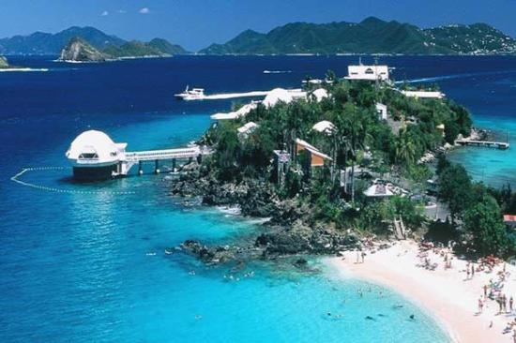
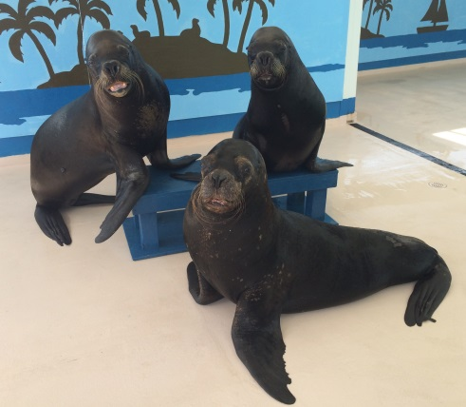
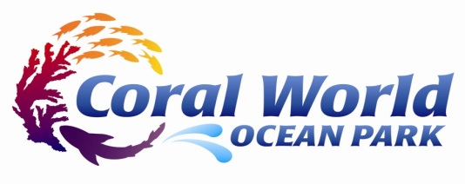

Sea Lion and
Tropical Bird Internship

Coral World Ocean Park is a privately owned marine park in the U.S. Virgin Islands. The park houses 3 South American sea lions who participate in a variety of interactive programs (both in and out of the water) and public presentations. Coral World is also home to a family of tropical birds, including 14 lorikeets and 2 macaws that live within an interactive guest exhibit and partake in daily guest feedings. We are looking for enthusiastic individuals who would like to gain experience in the field of animal training and husbandry.

This internship is designed to give the intern practical experience in the animal training and husbandry field for the purpose of career development. Interns will learn about all aspects of working in a marine mammal facility by working closely alongside trainers, completing an internship project, and participating in a 3-part development program:

Operation Modules- Teaches various operational duties involved with working at a marine mammal facility
Hands-On Training Progressions- Allows the intern to gain practical training experience by working directly with the sea lions and birds
Animal Training Lectures/Discussions- Discusses advanced animal training concepts and terminology through a series of power point lectures in a round table format

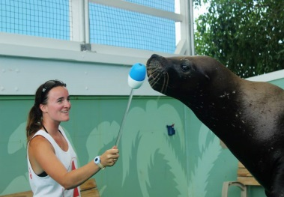
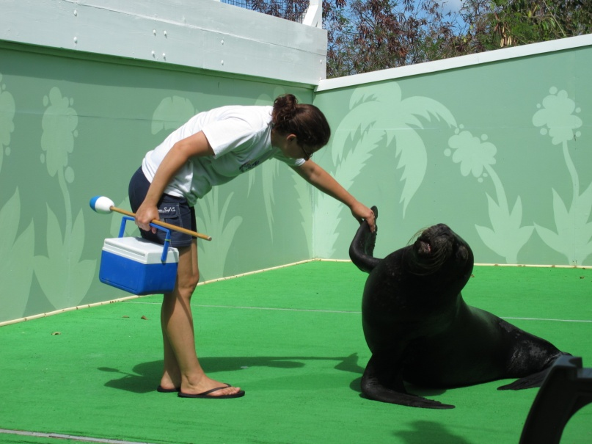
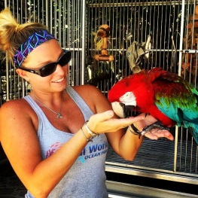
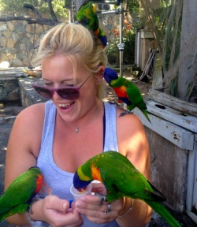
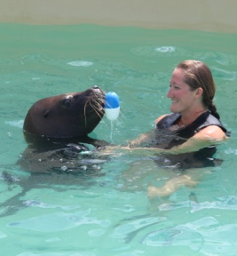
This is a very hands-on internship, where interns develop their knowledge by assisting with all elements of training of the animals. Our progressive program allows interns to learn and implement different animal training concepts as they advance through each stage of the internship. Our interns are a valuable part of our team and work right by our side!
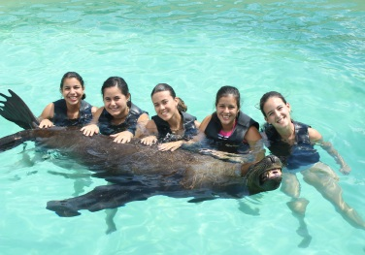
Essential Responsibilities
--Participate in the daily husbandry and behavior training of our resident sea lions and tropical birds
--Assist trainers with cleaning and maintenance, program photography, and diet preparation
--Interact with guests by assisting with animal programs and attending the lorikeet aviary
--Complete an individual internship project
Requirements
--Must be a current college student or recent graduate
--Must be physically fit and able to lift 60 pounds
--Must be a team player, have a positive attitude, and an outgoing personality
--Must be aware of the challenges of living on a Caribbean island (remote location, high cost of living, extreme heat, etc.)

Our interns are a part of a very close animal training team. We only bring in 2-3 interns at any one time (with overlapping start and end dates), with the program designed to run 3-6 months. Please submit a resume, cover letter, and letter of recommendation via email to Suki Meier at the email address below with Sea Lion Internship in the subject line.

Suki Meier
Marine Mammal Trainer II & Internship Coordinator
coralworldinternships@gmail.com
For more information about our facility, come visit our animals online!
Search for “Coral World Sea Lions” on Facebook or check out the Coral World website at coralworldvi.com!

