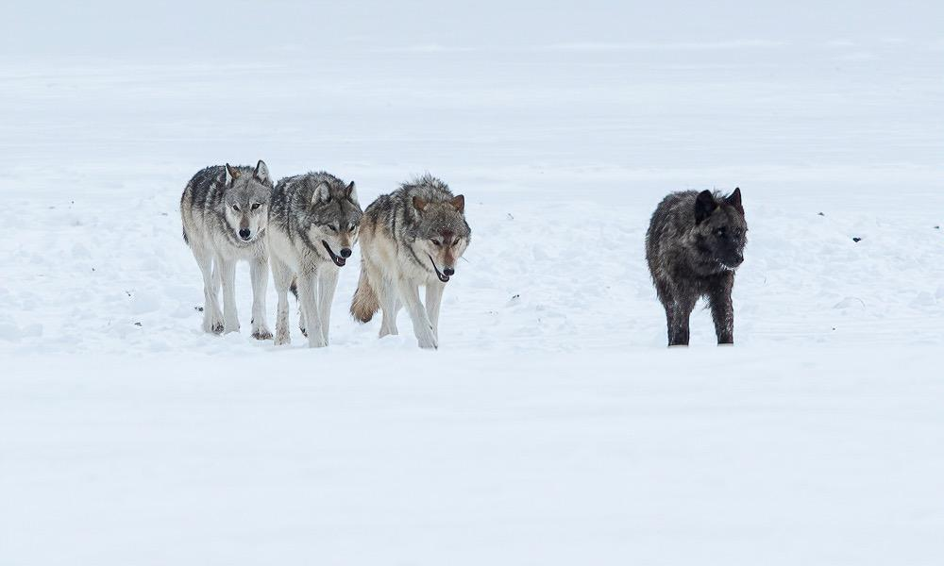

6-Day Winter Wolf Package

Six-Day All-Inclusive Package Tour
Overview
Spend 3 ½ days immersed in Yellowstone’s wildlife-rich Lamar Valley and Northern Range, highly revered as the very best place on Earth to see wild wolves. Lodging will be in a local family operated motel-style lodge, dinners will be in the comfort of our local boutique artist cafe, Wonderland, and evenings will be filled with presentations from local wildlife biologists, naturalists, artists, and storytellers. Each day provides new possibilities to see multiple wolf packs, frosty bison, long-legged moose, bighorn sheep, mountain goats, elk, otters, foxes, coyotes, eagles, owls and more. Your tour will also be highly educational, as we highlight the monumental reintroduction of wolves to Yellowstone, the complexities of wolf social behaviors, wolves’ specialized hunting strategies and their ecological impacts on the Yellowstone ecosystem. We will explore how these factors, and others, have captured the human imagination for centuries, and over time have characterized the wolf as the ultimate icon of Wilderness.
The deep snows of winter have pushed Yellowstone’s iconic wildlife down out of the mountains and onto their wintering grounds in the Lamar Valley and the Northern Range. Thousands of elk and bison, along with moose, bighorn sheep, white-tailed and mule deer and pronghorn have filtered out of the higher mountains of the Greater Yellowstone Ecosystem and have concentrated in the lower valleys and grasslands where there is less snow and less extreme temperatures. Winter can be tough on these grazing animals, and partially because of that, this is where Yellowstone’s wolves and other carnivores thrive.
This all-inclusive tour package is the ultimate way to experience the wild magic of Yellowstone National Park, while treating yourself to the comforts of homey accommodations and breakfasts and lunches catered by the Wonderland Cafe and enjoyed picnic-style out in the park, overlooking one of our favorite vistas in Yellowstone.
Dinners will be shared at the Wonderland Cafe with local artists, researchers and/or storytellers by the warmth of their inviting fireplace. Two evenings prior to dinner, we will be treated to a private presentation from a local Yellowstone wildlife/naturalist expert.
Tour Schedule Summary

Day | Location | Accommodation | General Comments
1 | Bozeman, MT | Bozeman, MT | Arrive in Bozeman  Check in to Hotel (free airport shuttle)
 |  | Best Western GranTree
2 | Gardiner, MT | Gardiner, MT | Pickup 10:00am @ Best Western in Bozeman, travel to Yellowstone  Sit-down lunch at Wonderland  Wildlife and Geology Day 1  Check in to Yellowstone River Motel
 |  | Yellowstone River Motel
3 | Gardiner, MT | Gardiner, MT | Meet guide @ 6:30am  Northern Range Wildlife Day 2 Evening Guest Speaker @ 5:00pm  Dinner @ Wonderland - 6:30pm
 |  | Yellowstone River Motel
4 | Gardiner, MT | Gardiner, MT | Meet guide @ 6:30am  Northern Range Wildlife Day 2 Guest speaker in field @ lunch  Dinner @ Wonderland - 6:30pm
 |  | Yellowstone River Motel
5 | Gardiner, MT | Gardiner, MT | Meet guide @ 6:30am  Northern Range Wildlife Day 2 Evening Guest Speaker @ 5:00pm  Dinner @ Wonderland - 6:30pm
 |  | Yellowstone River Motel
6 | Bozeman, MT | On own | Depart Gardiner for Bozeman @ 8:00am  Breakfast included along way  RETURN FLIGHTS SHOULD BE BOOKED NO EARLIER THAN 1:00PM
 |  | Drop off at airport or Bozeman lodging

What’s Included:

- One-night’s stay in Bozeman, MT
- Four-night’s stay in historic Gardiner, MT in the family-owned and operated Yellowstone River Motel at the North Entrance of Yellowstone National Park
- Round-trip transportation - Bozeman to Gardiner/Yellowstone
- Transportation in our fully-equipped touring vehicle(s) (we drive, you enjoy the scenery)
- Half-day tour of Mammoth Hot Springs and Gardiner Basin
- Three full-day (8 hours) guided wildlife tours in Yellowstone’s Northern Range
- Local naturalist guide(s)
- Dinners at Wonderland Dining Room - your guide will join on last night
- Private evening presentations with local wildlife experts 2 nights before dinner
- Guest speaker in the field during lunch on your second full tour day
- Snowshoes & trekking poles
- YakTraks (footwear traction devices)

Tour details

- Optics for everyone: top-of-the-line binoculars and high-powered spotting scopes for each guest
- Fresh-baked breakfast pastries
- Hot drinks (coffee, tea, hot cocoa)
- Healthy and hearty snacks (various bars and trail mix, etc.)
- Healthy fruit juice soft drinks and water
- Full picnic lunch (GF and vegetarian/vegan and kosher options available upon request)

- Dynamic and engaging discussions interpret the wildlife activity and behaviors we observe
- Informed and accurate information on the biology and conservation issues surrounding the wildlife you will observe on our tours
- Plenty of space in our vehicle(s) for your extra clothing *we provide detailed recommendations on appropriate winter clothing

There is a 3-person minimum for this tour to operate.

If you have booked with us and the trip does not fill within 30 days of the start date, you will be fully refunded the cost of your deposit.
We STRONGLY suggest purchasing flexible/refundable airline tickets

Price per person:
Double occupancy | Single occupancy
$2,850.00 | $3,475.00

Deposits
In order to hold your spot on this special trip, we require a $500.00 deposit upon booking. Full payment will be due 30 days prior to the beginning of your tour.

Cancellation Policy
​​​In case you need to cancel your trip with us, we will fully refund your deposit up to 31 days prior to the trip. Should the trip not meet the minimum participation to run, your deposit will be refunded in full. Any cancellation made 30 days or less before the starting day of your trip, will not be refunded.
WE HIGHLY RECOMMEND TRIP INSURANCE TO PROTECT YOUR INVESTMENT!!!

Trip Cancellation
We reserve the right to cancel the trip due to extreme weather conditions, events that would jeopardize the success of the expedition or other factors that are outside of our control. In the unlikely event your package cancels, full refunds will be given at that time.

Day 1
- Arrival at Bozeman International Airport -
- One night in Bozeman, Montana -
- Lodging at the Best Western GranTree*-

This package includes a one-night stay in Bozeman, Montana, walking distance to the historic downtown. Guests arriving to the Bozeman/Big Sky International Airport will be shuttled to the Best Western GranTree where you will stay this night. Please contact them directly @ (406) 587-5261) with 24-hours of your arrival to schedule your shuttle. You will be on your own this evening, so feel free to explore the exceptional dining and shopping options that Bozeman has to offer. The group will assemble by 10:00am the following morning in the hotel lobby where you will be met by your Naturalist Guide.

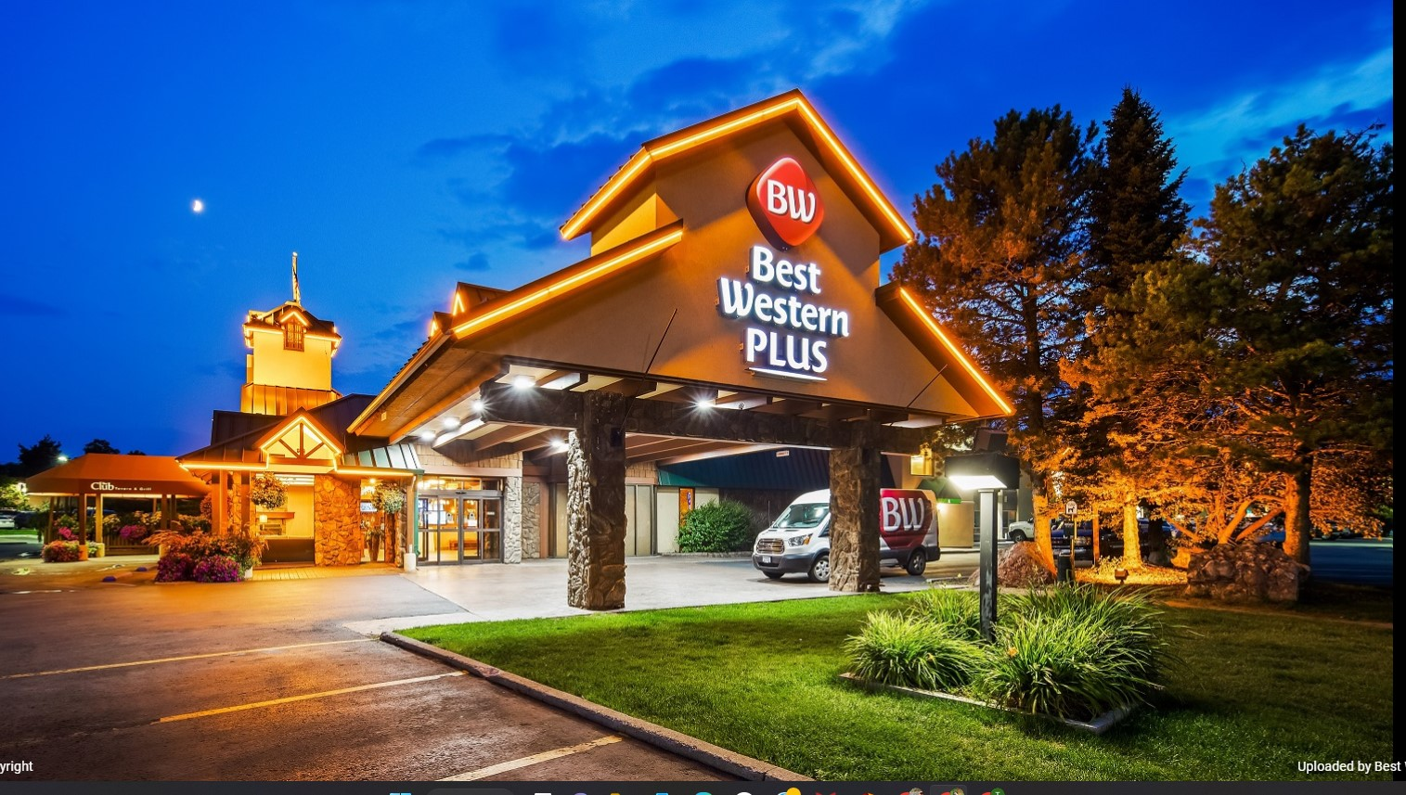

Day 2
- Pick-up in Bozeman and Transport to Gardiner, Montana -
- North Entrance to Yellowstone National Park -
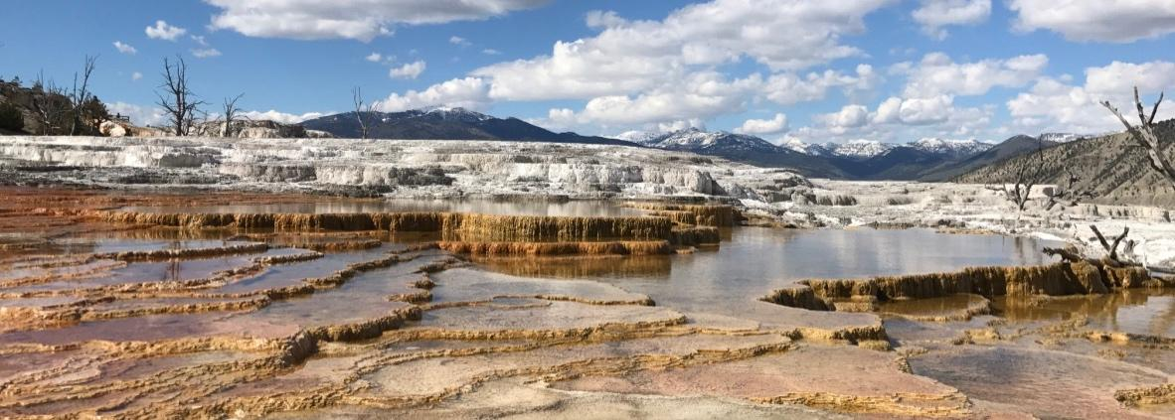
Breakfast is available starting at 6 AM in the hotel’s dining area. You will need to check out by 10 AM and have all your belongings in the hotel lobby.

We will meet in the hotel lobby at 10 AM, load up and begin our 1.5 - 2-hour drive through the Paradise Valley to Gardiner, Montana, at the north entrance of Yellowstone National Park.

Stopping along the way will give us the opportunity to experience and photograph the spectacular scenery of the Yellowstone River, Absaroka and Gallatin Mountains and the plentiful wildlife in the valley.

We will stop in Gardiner at the Wonderland Café for a sit-down lunch before spending the afternoon in the park. Upon entering Yellowstone, we will visit the unique geologic structures of the Mammoth Hot Springs complex enjoying the dramatic late afternoon light, while discovering the fascinating geologic story that has shaped Yellowstone’s incredible ecological processes.

Upon returning to Gardiner, your guide will assist you in checking into the Yellowstone River Motel, where you will be based for the next 4 nights. Dinner will be at 6:30pm at the nearby (within walking distance) Wonderland Cafe.

Days 3, 4 & 5
- Wildlife on the Northern Range 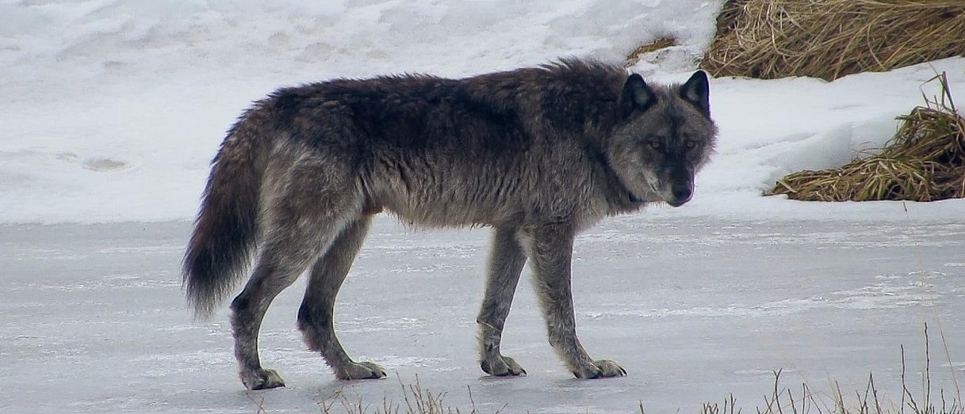

An early morning start at 6:00 or 6:30am (depending on time of year) allows us the privilege of positioning ourselves inside Yellowstone National Park’s Northern Range in the best places to find wolves and other wildlife before the first light. We will be able to access the territories of up to five different wolf packs, and we will spend our time in those areas with the best chances to locate and photograph wolves and their prey. Your guides know these wolves well and can often predict their movements, enabling us to position ourselves for the best viewing opportunities possible. We also have the privilege of first-hand information on wildlife locations through direct contact with the Yellowstone National Park wolf biologists, local wolf enthusiasts, professional photographers, and filmmakers. The exact areas we are visiting each day will be determined by the most current information on wildlife activity.

While focusing on these wolf packs, we will also have many opportunities to spend time with the other iconic Yellowstone wildlife species that concentrate in the lower elevation valley bottoms due to the heavy snow in the higher mountains. During these days, we may have the opportunity to observe and photograph wolf, bison, elk, mule deer, white-tailed deer, moose, pronghorn, bighorn sheep, mountain goat, coyote, fox, otter, beaver, bald eagle, golden eagle, raven, magpie, and possibly other rarer species.

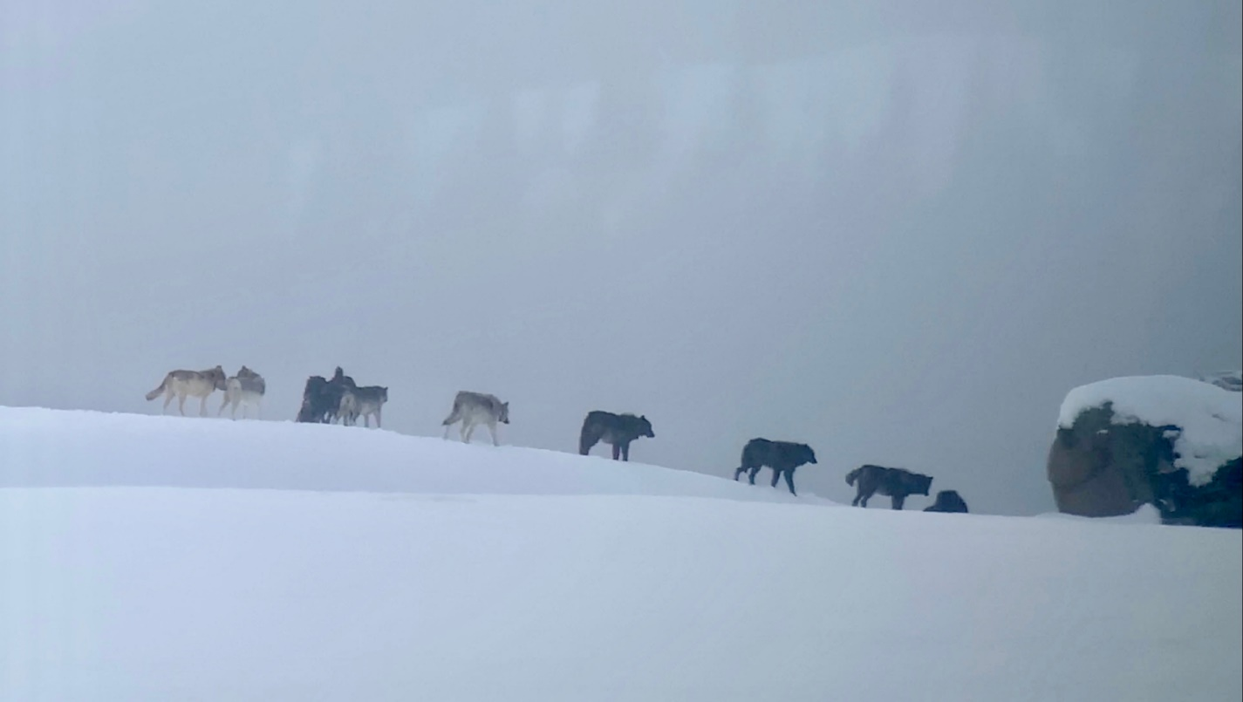
It is important to remember that the expanses in Yellowstone are vast and the animals are wild. As such, we cannot expect everything to be up close and personal. In fact, many of our sightings will be at considerable distances. Therefore, we provide you with the very best in optics for the greatest viewing enjoyment possible with each sighting. The binoculars and spotting scopes that we provide are the highest quality available and allow us to enjoy great views while maintaining a respectful distance from the wildlife that keeps both them and us safe.

On these days, your Naturalist Guide will be serving you hot drinks and fresh-baked pastries, as well as an assortment of snacks as we watch the birth of a new day in Yellowstone. It is common to be sipping your coffee and savoring a huckleberry scone when you hear your first wolf howl off in the distance. Your guides will work hard to locate wolves in that early morning light and then train everyone’s spotting scope onto the animals to observe them during the hours of their peak activity. We use our tour vehicles to quickly move from one viewing point to another to locate and observe this, and other, wildlife activity. We may be in and out of the vehicle several times at our favorite vantage points where we can comfortably set up our tripods, spotting scopes and cameras. At mid-day, we will serve a healthy and hearty picnic lunch overlooking one of our favorite views in the park and catered by the Wonderland Café. Vegetarian and gluten free dietary restrictions can be accommodated upon prior request. A moderate hike/snowshoe towards midday is an option if you would like to stretch the legs. We will have the opportunity to visit various different features of the park, depending on where the wildlife sightings take us throughout the morning, and we can discuss those options with you during the morning.
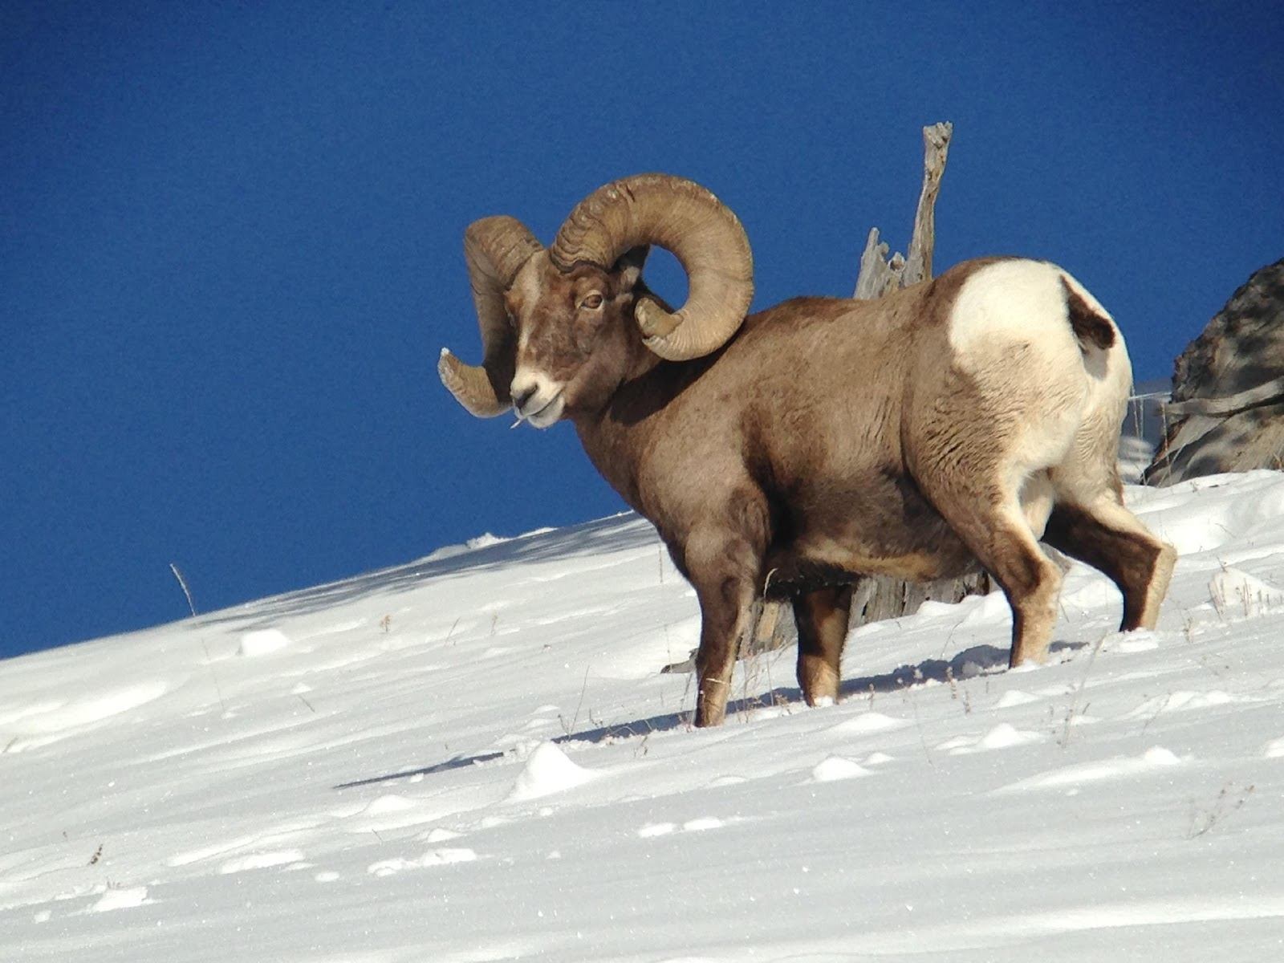

In the afternoons, wildlife sightings can be amazing as we work our way back towards Gardiner. Guests can plan on arriving back in Gardiner between 4-5 PM depending on the animals we find along the way.

Our dinners will be enjoyed in the comfort of the brand-new Wonderland Cafe in Gardiner, complete with a gourmet chef and full menus of exquisite food, beer and wine. A special guest presentation will follow dinner each evening with local biologists, authors and filmmakers in the Wonderland Lounge.

Each day we will visit many of the same areas in the northern portion of Yellowstone, and each day will offer new opportunities for finding and observing wildlife activity and behaviors. We often start our second and third days of wildlife watching by trying to pick up where we left off the afternoon before to discover what happens in the next chapter of the story of Yellowstone’s iconic wildlife.

Day 6
- Gardiner to Bozeman -

The final day of the trip will be a day of transition as we prepare for our departure from this magical place. On this day, we will have breakfast together before we part ways in Bozeman. We can provide a drop-off at the Bozeman Airport no earlier than 11:30 and we can arrange a drop-off at any other location in Bozeman for anyone wanting to stay longer in Big Sky Country.

