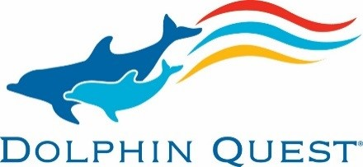
Dolphin Quest Crew Member Swim Test

Dolphin Quest makes safety a top priority for our crew. Our swim test ensures that those who will be interacting with our animals and/or immersed in their ocean environment have the skills to effectively do so safely. The outline of the swim test is available in advance of testing, so all crew have an opportunity to practice each skill prior to the test. The swim test will be required to successfully complete annually. We highly recommend that you practice in advance to ensure you can pass as jobs are contingent on this skillset.

Test Rules:
- Swimsuit and/or Wet suit only
- Mask or goggles optional per segment.
- Any job position that requires regularly entering the lagoon is required to pass this test.
- Individuals must pass all segments during the same test time to gain a pass. Segments can be completed in any order. Everyone gets two opportunities to pass any segment within one test time.
- Number of test times within a year is determined by the Manager of Marine Animals.

Test Components:
Distance Swim
Part 1: Feet first entry and swim from dock edge, turn and come back – 150 feet total
Criteria:
- Entry:
  - Head/eyes remain above the surface of the water
- Swim:
  - Demonstrates proficient swimming ability
  - Must be freestyle
  - Strokes look comfortable
- Turn
  - Turn under water without touching the bottom
- Time Limit:
  - 1:15

Tread Water
Part 2: 5-minute tread water – hands at shoulders
Criteria:
- Treading without lifejacket:
  - Any kick
- Hands:
  - All 10 fingers must remain above the surface of the water for the full time limit
- Able to comfortably engage in conversation as requested

Safe Exit
Part 3: Demonstrate a quick and safe exit from a variety of lagoon locations
Criteria:
- Exit from lagoon as requested by instructor
  - Swim quickly from mid lagoon to an exit point and exit in a timed manner
    - DQH
    - DQB
    - DQO

Distance breath hold
Part 4: Dive and swim underwater from dock to designated distance spot – 75 feet
Criteria:
- Entry:
  - Headfirst dive in or in water start.
  - Calm entry
- Underwater Swim (body underwater; no freestyle allowed)
  - Any stroke other than freestyle
- Finish
  - End point will be marked

Transport and recovery
Part 5: Surface dive to underwater transport and recovery (need to dive at least 11’)
Criteria:
- Surface dive
  - Start in the water
- Underwater Transport
  - Pick up a bucket of sand
  - Move the bucket 10 feet to a marked location
- Underwater Recovery
  - Pick up a weight and place on dock

End of Swim Test

