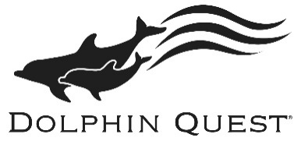
Dolphin Quest Bermuda - Internship Application

Please fill in the following information and rename the file with your full name when saving this document:
Full Name
Street Address
City
State
Zip Code/Country Code
Country
Citizenship
Cell Phone Number
Email

University
Major
Graduation Date or Expected Graduation Date

Describe specialized training or certifications (CPR/First Aid), apprenticeships, skills (swimming) and/or extracurricular activities, involvement in organizations (IMATA, AZA) that are relevant.
Session Preference (please check):
*please note due to the ever evolving Covid 19 pandemic, dates are subject to change
2021 – Session 1 (Tentative) (1/11/21 – 5/2/21)
2021 – Session 2 (5/10/21 – 9/3/21)
2021 – Session 3 (9/6/2021 – 1/7/22)
2022 – Session 1 (1/10/22 – 5/6/22)

Internship Program Preference (please check):
Marine Mammal Training Internship Level 1
Marine Mammal Training Internship Level 2
Marine Conservation Education Internship (available for Session 2 only)

I have noted the beginning and ending dates of this program, have checked my college schedule, and understand that I am committing to complete the entire program. I further understand that not completing the commitment will result in an incomplete for the internship.
Please type your initials here ___________

Reference Name | Phone Number | Email

How did you hear about our internship program? Please check all that apply.
 | Internet search (Google, Bing, etc.) |  | IMATA – web site or at conference
 | Participation at Dolphin Quest |  | Other organizations (like IMATA)
 | Word of mouth |  | Other (please list details below)

