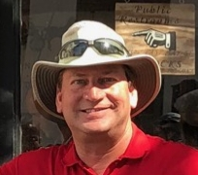
Coby Glass Bio
Coby is a 25+ year Veteran of the High-End Beer business and Certified Cicerone as well as a Registered Charleston Tour Guide.
His professional career began in 1990 and Coby has been a part of the Beverage Business in the Southeast ever since.
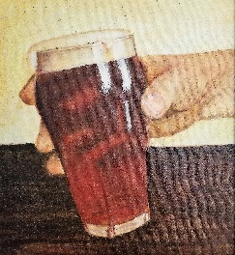
A few of his exploits include:
- Starring on an infomercial on late night TV in the early ‘90’s hawking Homebrew kits.
- Founder and first President of Ale Atlanta, a beer club instrumental in enhancing the awareness of Craft Beer and the judges for “The Best Beer in Atlanta”.
- Founding Member of Georgians for World Class Beer, an organization that fought to reform alcohol laws including the legalization of Homebrewing, Brew Pubs, Tasting Rooms, 6% laws, and Sunday sales.
- Host of “The Beer Guys” radio show. A regional Talk Show usually airing live on location at quality pubs and breweries throughout Atlanta.
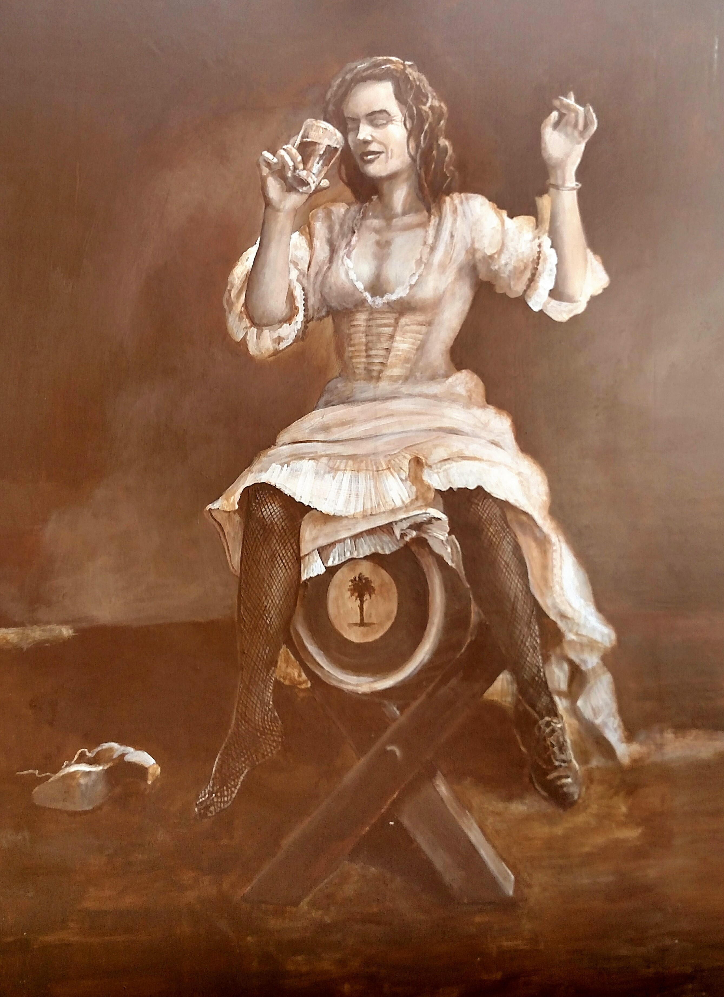
- Taught Beer 101 at Kennesaw State University.
- Former Director of Marketing- East Coast for Heineken.
- Managed the Southeast and Caribbean for Artisanal Imports- a high-end beer importer specializing in Belgian, Dutch, German, and Trappist beers.
- Currently hosts Historic Pub Tours in Charleston’s Old City featuring stories about Pubs, Pints, Prostitutes, Pirates, and Politics!
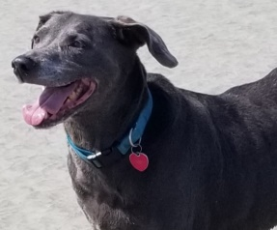
Coby resides in Mount Pleasant with his Blue Lacy Smoky and can likely be found having a pint with friends somewhere at any given moment….

