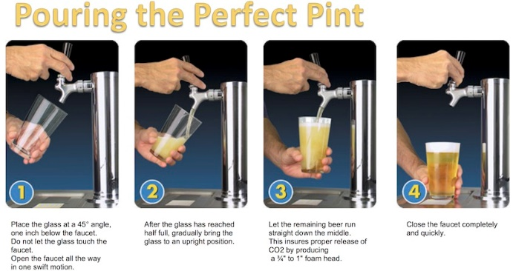
I remember it well. I was at a fairly new “gastropub” with a really nice beer selection. It was hot outside so so I took a seat at the bar, perused my draught options, and went with Andygator from Abita. A Helles Doppelbock with a slightly sweet flavor, Andygator has a subtle fruit aroma and a nice dry finish reaching an ABV of 8%. Plus Abita is a former employer and I tend to use loyalty as a tie-breaker.
When my beer arrived I was stunned. I literally just stared at it for a moment. I eventually took a picture. It was horrible. Poured to the rim in a dirty shaker pint with no head at all. How did I know it was dirty? I’ll tell you in a moment….
But first, what does this have to do with our Charleston Beer District? Well Charleston was a bit late to the Craft Brewery Party and now we are making up for lost time. As of this writing we have 27 breweries in the area and may have 30 by the time “the season” is over. That means a lot of new staffing and a lot of folks on both sides of the bar that don’t know how, or why, a proper pour is so important. So as succinctly as possible here are a few of the key points:
- Use a damn glass. Seriously. If you are drinking a professionally crafted brewer’s masterpiece straight out of the bottle or can you should have your beer drinker’s card revoked. The carbonation in beer needs to be released to maximize flavor- but you also don’t want to swallow it in liquid form. It will convert to gas and make you feel bloated before finding a way out of one of your bodily orifices.
- “Beer clean” is a thing. Beer will stick to the residual gunk in a dirty glass in the form of nucleation points. One of several things you can judge a proper pour on before taking your first sip. A few little dots aren’t going to hurt you so don’t be a PITA (Pain In The…) and complain, but if there are big clusters of bubbles on the glass politely ask for another. As you enjoy your beer notice the nice lacing on the “beer clean” glass.
- Good Head. Once you get used to it being done right you don’t ever want to go back. You sense more flavor with your nose than your mouth so don’t waste it. The head on your beer should reasonably be at least the width of your finger. Purists say an inch or more- but bartenders don’t want to be bitched at either so compromise with the finger. So to speak….
As for my dirty glass of Andygator, I summoned the bartender when she finished looking at her phone. Before I could finish explaining my issue she interrupted me to explain she was the co-owner along with her husband. I considered handing back the lunch menu and going elsewhere, but went diplomat on her and patiently explained my dilemma. A dirty glass is like someone spitting in your pizza- it probably won’t hurt you, but you don’t want to KNOW it. She let me behind her bar and I showed her a proper pour. I later conducted a staff training and they are still in business today.
I kinda think I helped….
Cheers!
Coby Glass / @CobyGlass

