Planning Your Trip
When you visit Black Spruce Dog Sledding, you are visiting the home of Jeff & KattiJo Deeter. We love visitors, but we have two simple requests:
1.Please make your tour reservation in advance – online or over the phone
2.Please do not arrive more than 15 minutes before your scheduled tour
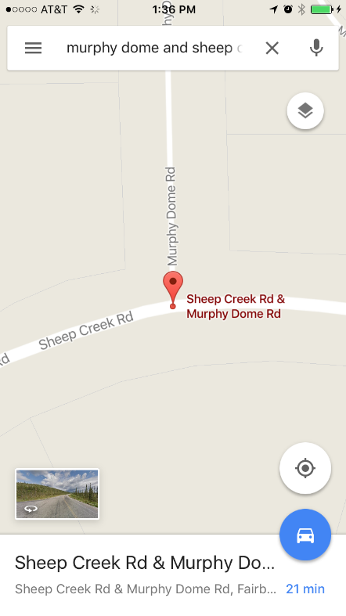
--------------------------------------------------------------
Let The Adventure Begin…
Do: Turn on your GPS or open a navigational app like Google Maps or Waze
Do: Navigate to the intersection of “Murphy Dome Road & Sheep Creek Road”
If you can’t find this intersection, search for Ivory Jack’s Restaurant instead. This is a fun place to eat, and about 2 minutes east of the intersection you’re looking for.
Do: Turn onto Murphy Dome Road
[You are now about 30 minutes away from Black Spruce Dog Sledding]
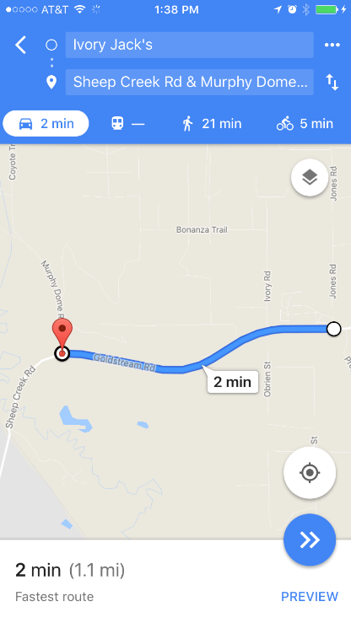
Don’t: Attempt to by-pass this first step on your drive by navigating to other places or roads (like Errol Ave). You must pass through this intersection to get to our location.
Don’t: Get confused by road names here… Sheep Creek Road and Goldstream Road/Highway are basically the same road. You will also encounter both Murphy Dome Road and OLD Murphy Dome Road on your drive. These are not the same roads.
(Driving directions continue below photos)

Do: Turn on to Murphy Dome Road
Do: Drive for 2 miles on Murphy Dome Road
Do: Turn right on Spinach Creek Road
Do: ​Drive on Spinach Creek Road for 4.8 miles until it ends in a T-intersection at OLD Murphy Dome Road (directions continue below photos)
[You are now about 10 minutes away from Black Spruce Dog Sledding]
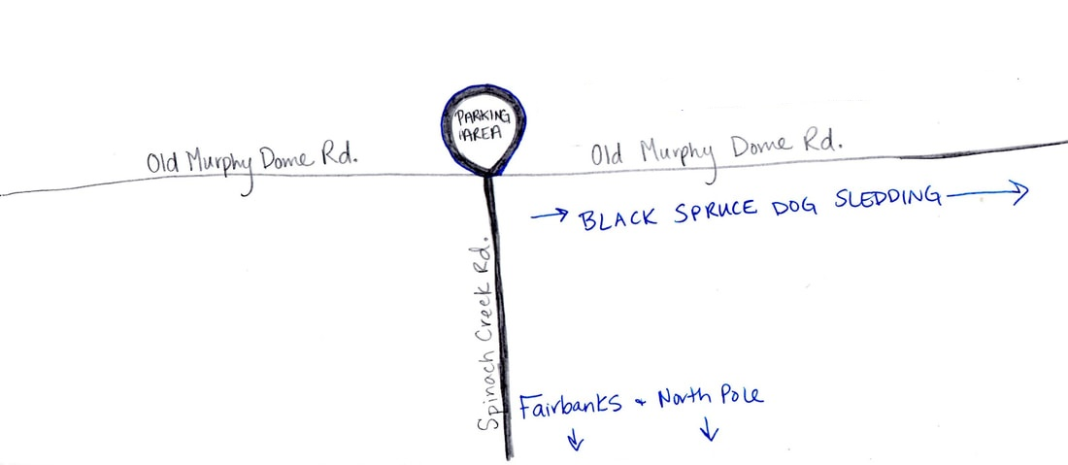

Pro Tip: There is a parking area at this intersection. If it looks like you’ll be more than 15 minutes early for your tour, please park here and hang out for awhile. This is a beautiful spot for taking pictures. This is also a good spot to open any heat packs you may have with you (winter) or put on bug spray (summer).

Don’t: Park here if you think you’ll get stuck! If the snow or mud is very deep, park on the side of the road instead. Not sure? Get out and feel how stable the ground is with your feet.

Don’t: Get overdressed here. Since your car is warm, you shouldn’t be wearing all of your winter layers while you drive. If you get warm and sweaty in the car, you’re going to be cold later when you’re outside with the dogs.
Do: Turn right (east) on Old Murphy Dome Road. That’s a right as you’re coming up Spinach Creek facing the stop sign.
Don’t: Get confused here. If you’ve been parked in the clearing, think really carefully about which direction you need to go to continue your drive. Use the illustration above if you’re not sure.
Do: Look at your odometer as you start driving down Old Murphy Dome Road. You want to drive for approximately 4 miles and look for McCall Street on your left. You will drive for quite some time on Old Murphy Dome without seeing any turns. Eventually you will see Darling Avenue on your left (do not turn on Darling Avenue!) Then you’ll see a driveway on your left. Then the next turn on the left will be McCall Street. Turn left on McCall Street.

Don’t: Rely on your GPS, cell service or road signs here. You’re in rural Alaska now. Your GPS and cell service may be spotty, and road signs may be blown over or covered in snow. Counting the left turns, and using your odometer will be the most helpful tool you have for finding McCall Street.
Don’t: Miss the turn for McCall Street. If you miss the turn you can get seriously stuck in the mud (summer) or the snow (winter).
Don’t: Speed! Please drive slowly through our neighborhood!!! As you turn on McCall Street you are officially entering a residential area, although it may not seem like it. Please keep your speed at or under 25 mph.

Do: Drive on McCall Street for .9 miles and look for Errol Avenue on your left.
Do: Turn left on Errol Ave.
Do: Look for our Black Spruce Dog Sledding business sign on the right. Turn right into the driveway with the business sign.
Don’t: Choose the wrong driveway. Our property has two driveways. The first one doesn’t have a business sign, although you will be able to see our house from the road. Please use the designated driveway only.
Don’t: Be more than 15 minutes early. If you got the memo the first time, and don’t need this third reminder we are truly sorry! We love our visitors, and we’re grateful to have you here. But we want to make your visit a great one. Please give us time to prepare our home for you. If you’re more than 15 minutes early, please park in the cul-de-sac at the end of our road.
Do: Park at the traffic cones. You’ve made it to your dog sledding treasure!
Don’t: Park in front of our house. It’ll be an inconveniently longer walk for you, and it could block access for us.

Welcome to Black Spruce Dog Sledding!
