**Step-by-Step Driving Directions**

*\*Note: These detailed instructions may seem like way more information than what you think you need, but for some visitors, these little bits of info are essential. This guidance is meant to be helpful, not condescending. Please read carefully.*

First turn on your GPS, and search for directions to the intersection of **“Murphy Dome and Sheep Creek Road.”** This intersection is about 15 minutes drive north of the Fairbanks city center, and about 30 minutes drive south of our location.

*Do NOT attempt to by-pass this first important step in our driving directions by using your GPS to search for other roads (such as Errol Ave) instead. Getting yourself to the intersection of Murphy Dome Road and Sheep Creek Road is crucial. There is no other way to get to our location other than via this intersection. If your GPS is telling you to use the Elliot Highway to get to our place than you have done something wrong in your search. Stay off of the Elliot Highway.*

If you are having a hard time locating the intersection of “Murphy Dome and Sheep Creek Road” you can search for **“Ivory Jack’s Restaurant”** instead. This restaurant is about 1 mile east of the intersection.

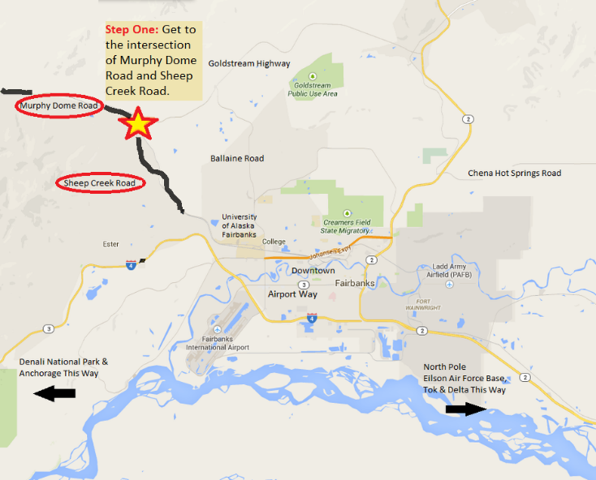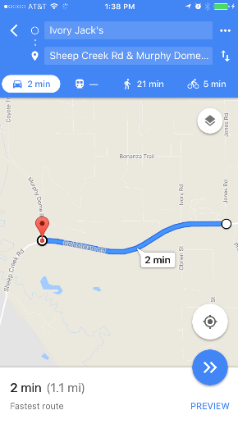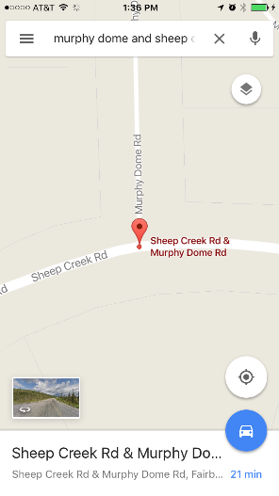

Next, turn on to **Murphy Dome Road** (Important: You will encounter both “Murphy Dome Road” and “Old Murphy Dome Road” enroute to our location. Don’t be confused. These are two very different roads.)

Drive for 2 miles on Murphy Dome Road. **Turn right on Spinach Creek Road.**

*(Directions continued on next page.)*

Drive on Spinach Creek Road for 4.8 miles. This is a long, up-hill drive. Finally Spinach Creek Road will form a T-intersection with Old Murphy Dome Road.

At the intersection of Spinach Creek Road and Old Murphy Dome Road, you are about 6 miles away from our home (approx. 10 more minutes drive time if conditions are good). You now have two options…

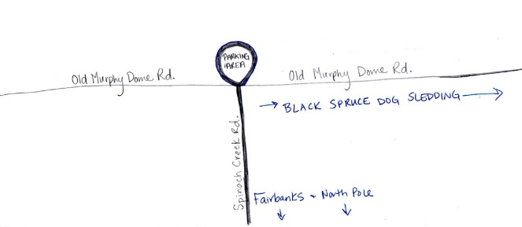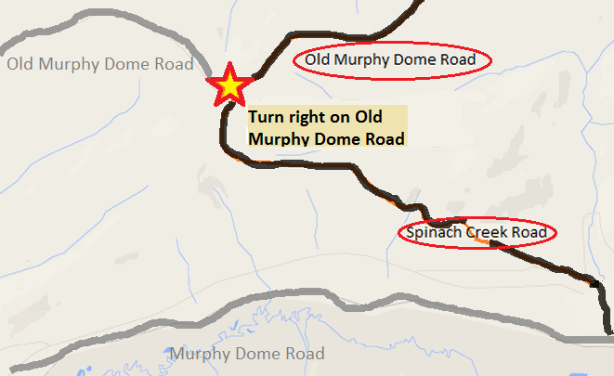

*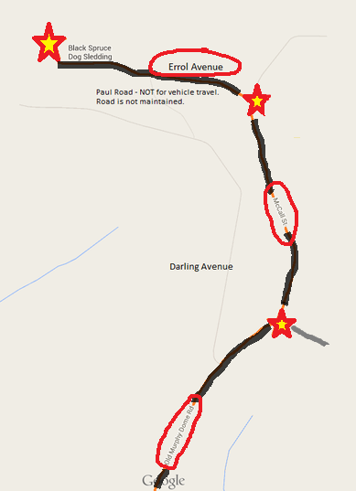***If you’re running ahead of schedule,** we ask that you park in the small clearing across the road and wait until closer to your designated tour time to continue your drive. Please use common sense when deciding whether or not to park here. Sometimes this area is too muddy or snowy for parking and your vehicle will get stuck if you try to pull in here. If you’re not sure, get out and feel how stable the ground is with your feet. In general this area is a great place to enjoy the view and take some pictures. You may also want to use this opportunity to start putting on some warm winter clothes like snowpants and boots. We don’t suggest putting on jackets, facemasks, hats or gloves just yet, for risk of over-heating and sweating during the remainder of your drive. Sweating in your layers can make you cold later. This is also a good spot to open up your hand/foot warmers if you think you will want those on the tour. These take several minutes of air exposure to begin to get warm.

If you’re ready to keep driving, **turn RIGHT on Old Murphy Dome Road.**

Drive for approximately 4 miles on Old Murphy Dome Road. Look for **McCall Street on your left.** (Do NOT turn down Darling Avenue no matter what your GPS says!)

*(Directions continued on next page.)*

**Turn left on McCall Street.** If you continue driving straight instead of turning left on McCall, you will notice the road suddenly becomes very narrow, full of deep ruts, holes and gets extremely difficult to drive. Old Murphy Dome Road becomes a trail at this point, and is no longer a passable road. You’ve gone too far.

Road conditions in our neighborhood are usually pretty good here – especially in late summer. Please resist the temptation to speed now. You have officially entered our neighborhood and we want to keep our neighbors happy. Reduce your speed to 35 mph or less. Drive for .9 miles and look for Errol on your left.

**Turn left on Errol Ave.** If you miss the turn for Errol Ave you will again notice the road you are on will suddenly become very narrow and difficult to drive. McCall Street becomes a trail at this point. You’ve gone too far.

Drive for **.7 miles to find Black Spruce Dog Sledding near the end of the road on the right** hand side. There is a large business sign at the end of our driveway. But wait!

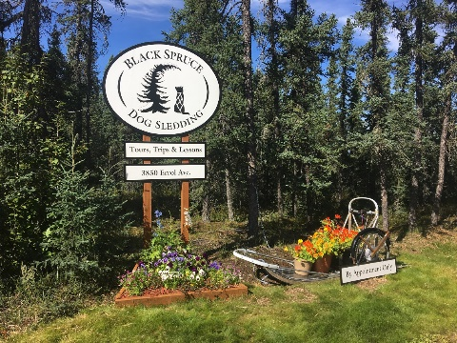

**Are you early?** If you are more than 15 minutes early for your tour, please park at the end of the road in the nice, big cul-de-sac and wait for your designated tour time. We want to make your first impression a great one! We need time to prepare for you and say good bye to departing groups. Remember you are visiting our home – parking space and staff are limited.

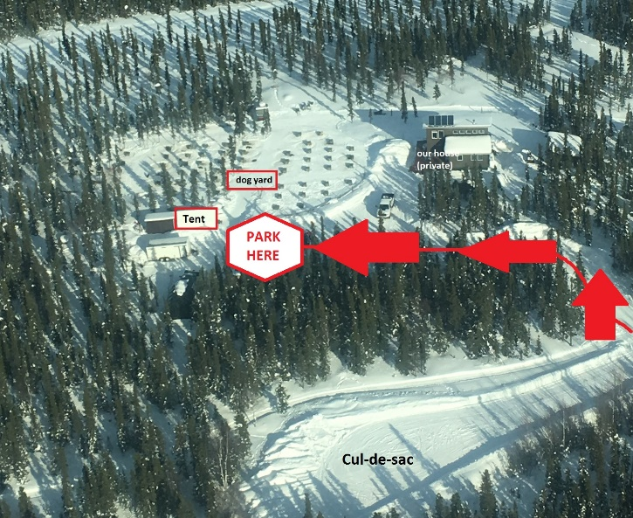

As you drive in, look for the **parking signs, traffic cones, or other designations telling you where to park.** We do not run tours out of our physical house. Instead, we have a sturdy, square, white canvas tent we use as our visitor “meet and greet” area. Look for this white tent on the far side of our dog yard and park near the tent. We’ll try our best to come out and meet you.

**Welcome!**